Android Lab Cycle 1

1. Design a simple calculator, and set properties using .xml file.

**activity_main.xml**

<?xml version="1.0" encoding="utf-8"?>  
<androidx.constraintlayout.widget.ConstraintLayout xmlns:android="http://schemas.android.com/apk/res/android"  
 xmlns:app="http://schemas.android.com/apk/res-auto"  
 xmlns:tools="http://schemas.android.com/tools"  
 android:layout_width="match_parent"  
 android:layout_height="match_parent"  
 android:backgroundTint="#B73A53"  
 tools:context=".MainActivity">  
  
 <Button  
 android:id="@+id/button18"  
 android:layout_width="56dp"  
 android:layout_height="47dp"  
 android:background="#FFEB3B"  
 android:text="1"  
 android:textAppearance="@style/TextAppearance.AppCompat.Small"  
 tools:layout_editor_absoluteX="47dp"  
 tools:layout_editor_absoluteY="361dp" />  
  
 <Button  
 android:id="@+id/button19"  
 android:layout_width="56dp"  
 android:layout_height="47dp"  
 android:background="#9C27B0"  
 android:text="9"  
 android:textAppearance="@style/TextAppearance.AppCompat.Small"  
 tools:layout_editor_absoluteX="242dp"  
 tools:layout_editor_absoluteY="509dp" />  
  
 <Button  
 android:id="@+id/button20"  
 android:layout_width="56dp"  
 android:layout_height="47dp"  
 android:background="#5A712E"  
 android:text="6"  
 android:textAppearance="@style/TextAppearance.AppCompat.Small"  
 tools:layout_editor_absoluteX="242dp"  
 tools:layout_editor_absoluteY="439dp" />  
  
 <Button  
 android:id="@+id/button21"  
 android:layout_width="56dp"  
 android:layout_height="47dp"  
 android:background="#FF9800"  
 android:text="3"  
 android:textAppearance="@style/TextAppearance.AppCompat.Small"  
 tools:layout_editor_absoluteX="242dp"  
 tools:layout_editor_absoluteY="361dp" />  
  
 <Button  
 android:id="@+id/button22"  
 android:layout_width="56dp"  
 android:layout_height="47dp"  
 android:background="#9C27B0"  
 android:text="8"  
 android:textAppearance="@style/TextAppearance.AppCompat.Small"  
 tools:layout_editor_absoluteX="148dp"  
 tools:layout_editor_absoluteY="509dp" />  
  
 <Button  
 android:id="@+id/button23"  
 android:layout_width="56dp"  
 android:layout_height="47dp"  
 android:background="#FFC107"  
 android:text="2"  
 android:textAppearance="@style/TextAppearance.AppCompat.Small"  
 tools:layout_editor_absoluteX="148dp"  
 tools:layout_editor_absoluteY="361dp" />  
  
 <Button  
 android:id="@+id/button15"  
 android:layout_width="56dp"  
 android:layout_height="47dp"  
 android:background="#00BCD4"  
 android:text="AC"  
 android:textAppearance="@style/TextAppearance.AppCompat.Small"  
 tools:layout_editor_absoluteX="329dp"  
 tools:layout_editor_absoluteY="657dp" />  
  
 <Button  
 android:id="@+id/button16"  
 android:layout_width="56dp"  
 android:layout_height="47dp"  
 android:background="#CDDC39"  
 android:text="5"  
 android:textAppearance="@style/TextAppearance.AppCompat.Small"  
 tools:layout_editor_absoluteX="148dp"  
 tools:layout_editor_absoluteY="439dp" />  
  
 <Button  
 android:id="@+id/button17"  
 android:layout_width="56dp"  
 android:layout_height="47dp"  
 android:background="#CDDC39"  
 android:text="7"  
 android:textAppearance="@style/TextAppearance.AppCompat.Small"  
 tools:layout_editor_absoluteX="47dp"  
 tools:layout_editor_absoluteY="509dp" />  
  
 <Button  
 android:id="@+id/button13"  
 android:layout_width="56dp"  
 android:layout_height="47dp"  
 android:background="#FFEB3B"  
 android:text="4"  
 android:textAppearance="@style/TextAppearance.AppCompat.Small"  
 tools:layout_editor_absoluteX="47dp"  
 tools:layout_editor_absoluteY="439dp" />  
  
 <Button  
 android:id="@+id/button14"  
 android:layout_width="56dp"  
 android:layout_height="47dp"  
 android:background="#9C27B0"  
 android:text="C"  
 android:textAppearance="@style/TextAppearance.AppCompat.Small"  
 tools:layout_editor_absoluteX="242dp"  
 tools:layout_editor_absoluteY="590dp" />  
  
 <Button  
 android:id="@+id/button12"  
 android:layout_width="56dp"  
 android:layout_height="47dp"  
 android:background="#F44336"  
 android:text="0"  
 android:textAppearance="@style/TextAppearance.AppCompat.Small"  
 tools:layout_editor_absoluteX="47dp"  
 tools:layout_editor_absoluteY="585dp" />  
  
 <Button  
 android:id="@+id/button10"  
 android:layout_width="53dp"  
 android:layout_height="40dp"  
 android:background="#FF9800"  
 android:text="+"  
 tools:layout_editor_absoluteX="329dp"  
 tools:layout_editor_absoluteY="509dp" />  
  
 <Button  
 android:id="@+id/button11"  
 android:layout_width="53dp"  
 android:layout_height="42dp"  
 android:background="#03A9F4"  
 android:text="/"  
 tools:layout_editor_absoluteX="329dp"  
 tools:layout_editor_absoluteY="590dp" />  
  
 <Button  
 android:id="@+id/button9"  
 android:layout_width="51dp"  
 android:layout_height="43dp"  
 android:background="#2196F3"  
 android:text="*"  
 tools:layout_editor_absoluteX="329dp"  
 tools:layout_editor_absoluteY="361dp" />  
  
 <Button  
 android:id="@+id/button8"  
 android:layout_width="50dp"  
 android:layout_height="45dp"  
 android:background="#FFC107"  
 android:text="-"  
 tools:layout_editor_absoluteX="329dp"  
 tools:layout_editor_absoluteY="439dp" />  
  
 <Button  
 android:id="@+id/button"  
 android:layout_width="54dp"  
 android:layout_height="48dp"  
 android:background="#E91E63"  
 android:text="="  
 tools:layout_editor_absoluteX="150dp"  
 tools:layout_editor_absoluteY="585dp" />  
  
 <TextView  
 android:id="@+id/textView"  
 android:layout_width="395dp"  
 android:layout_height="256dp"  
 android:layout_marginTop="84dp"  
  
 app:layout_constraintTop_toTopOf="parent"  
 tools:layout_editor_absoluteX="8dp" />  
  
 <TextView  
 android:id="@+id/textView2"  
 android:layout_width="412dp"  
 android:layout_height="88dp"  
 android:background="#673AB7"  
 android:gravity="center"  
 android:text="CALCULATOR"  
 android:textSize="34sp"  
 tools:layout_editor_absoluteX="2dp"  
 tools:layout_editor_absoluteY="-2dp" />  
  
</androidx.constraintlayout.widget.ConstraintLayout>

**Output**

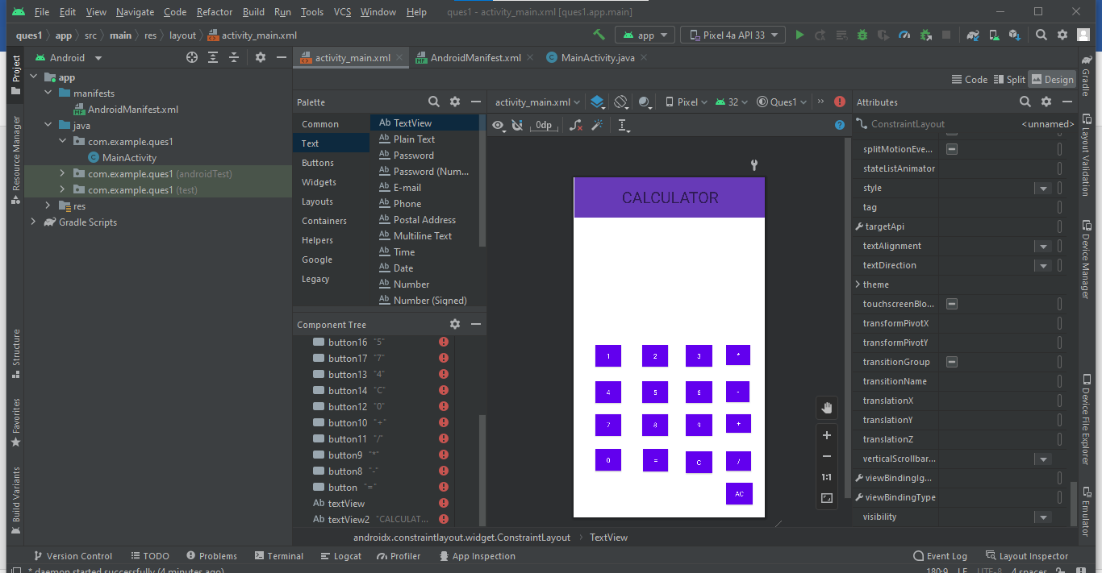

1. Develop an application for a simple registration page using .xml file.

**activity_main.xml**

<?xml version="1.0" encoding="utf-8"?>  
<androidx.constraintlayout.widget.ConstraintLayout xmlns:android="http://schemas.android.com/apk/res/android"  
 xmlns:app="http://schemas.android.com/apk/res-auto"  
 xmlns:tools="http://schemas.android.com/tools"  
 android:layout_width="match_parent"  
 android:layout_height="match_parent"  
 tools:context=".MainActivity">  
  
 <TextView  
 android:layout_width="142dp"  
 android:layout_height="56dp"  
 android:text="SIGN UP!"  
 android:textColor="#009688"  
 android:textColorLink="#009688"  
 android:textSize="34sp"  
 app:layout_constraintBottom_toBottomOf="parent"  
 app:layout_constraintEnd_toEndOf="parent"  
 app:layout_constraintHorizontal_bias="0.457"  
 app:layout_constraintStart_toStartOf="parent"  
 app:layout_constraintTop_toTopOf="parent"  
 app:layout_constraintVertical_bias="0.121" />  
  
 <EditText  
 android:id="@+id/editTextTextPersonName"  
 android:layout_width="wrap_content"  
 android:layout_height="wrap_content"  
 android:ems="10"  
 android:inputType="textPersonName"  
 android:gravity="center"  
 android:hint="Username"  
 tools:layout_editor_absoluteX="89dp"  
 tools:layout_editor_absoluteY="173dp" />  
  
 <EditText  
 android:id="@+id/editTextTextPersonName2"  
 android:layout_width="wrap_content"  
 android:layout_height="wrap_content"  
 android:ems="10"  
 android:inputType="textPersonName"  
 android:hint="Email"  
 android:gravity="center"  
 tools:layout_editor_absoluteX="89dp"  
 tools:layout_editor_absoluteY="248dp" />  
  
 <EditText  
 android:id="@+id/editTextTextPersonName3"  
 android:layout_width="wrap_content"  
 android:layout_height="wrap_content"  
 android:ems="10"  
 android:inputType="textPersonName"  
 android:gravity="center"  
 android:hint="Address"  
 tools:layout_editor_absoluteX="89dp"  
 tools:layout_editor_absoluteY="321dp" />  
  
 <EditText  
 android:id="@+id/editTextTextPersonName4"  
 android:layout_width="wrap_content"  
 android:layout_height="wrap_content"  
 android:hint="Username"  
  
 android:gravity="center"  
 android:inputType="textPersonName"  
 android:hint="Gender"  
 tools:layout_editor_absoluteX="89dp"  
 tools:layout_editor_absoluteY="414dp" />  
  
 <EditText  
 android:id="@+id/editTextTextPassword"  
 android:layout_width="wrap_content"  
 android:layout_height="wrap_content"  
 android:ems="10"  
 android:gravity="center"  
 android:hint="Password"  
 android:inputType="textPassword"  
 tools:layout_editor_absoluteX="89dp"  
 tools:layout_editor_absoluteY="491dp" />  
  
 <EditText  
 android:id="@+id/editTextTextPassword2"  
 android:layout_width="wrap_content"  
 android:layout_height="wrap_content"  
 android:ems="10"  
 android:gravity="center"  
 android:hint="Confirm Password"  
 android:inputType="textPassword"  
 tools:layout_editor_absoluteX="89dp"  
 tools:layout_editor_absoluteY="557dp" />  
  
 <Button  
 android:id="@+id/button"  
 android:layout_width="97dp"  
 android:layout_height="55dp"  
 android:backgroundTint="#009688"  
 android:text="SIGN UP"  
 tools:layout_editor_absoluteX="144dp"  
 tools:layout_editor_absoluteY="649dp" />  
  
</androidx.constraintlayout.widget.ConstraintLayout>

**Output**

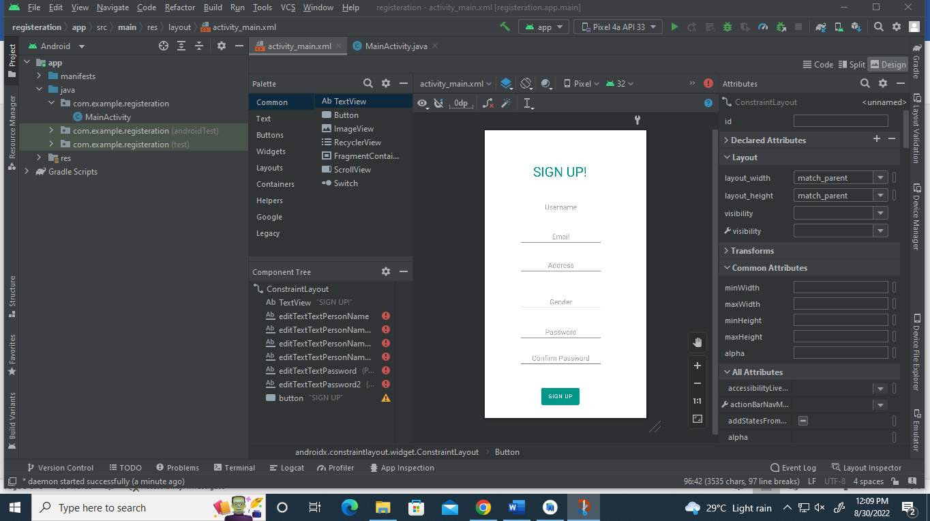

1. Design an application for the login page using .xml file.

**activity_main.xml**

1. <?xml version="1.0" encoding="utf-8"?>  
   <androidx.constraintlayout.widget.ConstraintLayout xmlns:android="http://schemas.android.com/apk/res/android"  
    xmlns:app="http://schemas.android.com/apk/res-auto"  
    xmlns:tools="http://schemas.android.com/tools"  
    android:layout_width="match_parent"  
    android:layout_height="match_parent"  
    tools:context=".MainActivity">  
     
    <EditText  
    android:id="@+id/editTextTextPassword"  
    android:layout_width="wrap_content"  
    android:layout_height="wrap_content"  
    android:ems="10"  
    android:inputType="textPassword"  
    android:text="password"  
    tools:layout_editor_absoluteX="89dp"  
    tools:layout_editor_absoluteY="343dp" />  
     
    <TextView  
    android:id="@+id/textView"  
    android:layout_width="172dp"  
    android:layout_height="67dp"  
    android:text="SIGN IN"  
    android:textColor="#009688"  
    android:textSize="48sp"  
    tools:layout_editor_absoluteX="101dp"  
    tools:layout_editor_absoluteY="156dp" />  
     
    <Button  
    android:id="@+id/myButton"  
    android:layout_width="169dp"  
    android:layout_height="55dp"  
    android:layout_marginTop="440dp"  
    android:backgroundTint="#009688"  
    android:text="SIGN IN"  
    app:layout_constraintHorizontal_bias="0.429"  
    app:layout_constraintLeft_toLeftOf="parent"  
    app:layout_constraintRight_toRightOf="parent"  
    app:layout_constraintTop_toTopOf="parent" />  
     
    <EditText  
    android:id="@+id/editTextTextPersonName2"  
    android:layout_width="wrap_content"  
    android:layout_height="wrap_content"  
    android:ems="10"  
    android:inputType="textPersonName"  
    android:text="Username"  
    tools:layout_editor_absoluteX="89dp"  
    tools:layout_editor_absoluteY="274dp" />  
   </androidx.constraintlayout.widget.ConstraintLayout>

**Output**

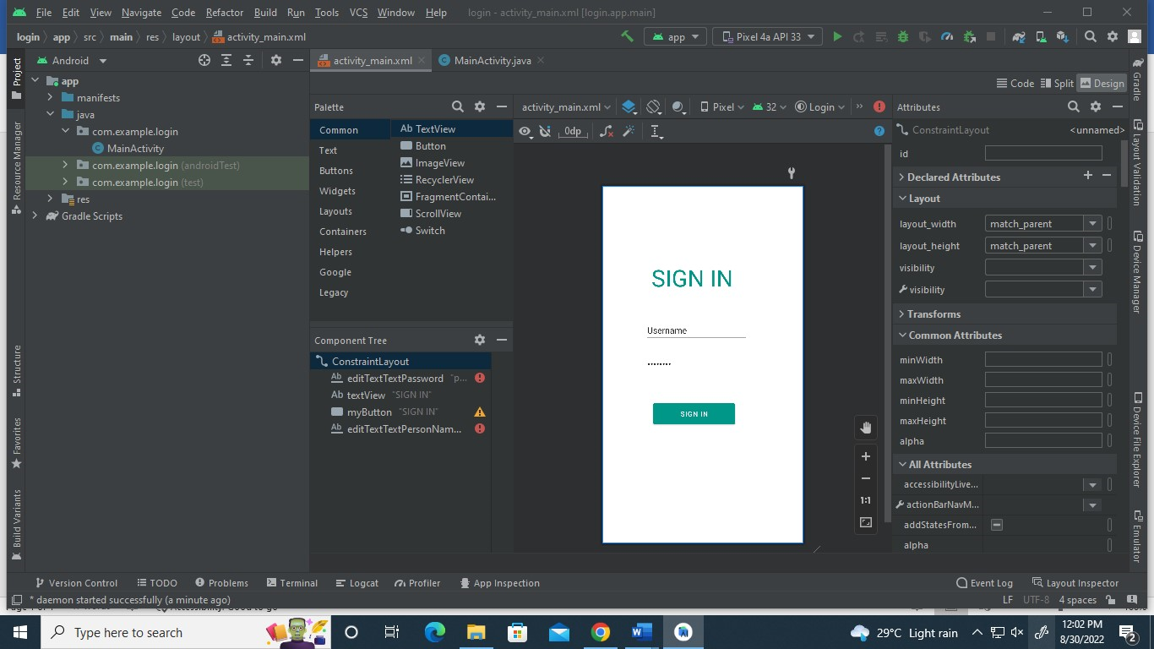

1. Develop your Profile page using .xml file.

**activity_main.xml**

<?xml version="1.0" encoding="utf-8"?>  
<androidx.constraintlayout.widget.ConstraintLayout xmlns:android="http://schemas.android.com/apk/res/android"  
 xmlns:app="http://schemas.android.com/apk/res-auto"  
 xmlns:tools="http://schemas.android.com/tools"  
 android:layout_width="match_parent"  
 android:layout_height="match_parent"  
 android:background="#FFFFFF"  
 tools:context=".MainActivity">  
  
 <TextView  
 android:id="@+id/textView2"  
 android:layout_width="168dp"  
 android:layout_height="36dp"  
 android:gravity="center"  
 android:text="Malavika A"  
 android:textSize="20sp"  
 tools:layout_editor_absoluteX="168dp"  
 tools:layout_editor_absoluteY="96dp" />  
  
 <TextView  
 android:id="@+id/textView3"  
 android:layout_width="164dp"  
 android:layout_height="23dp"  
 android:gravity="center"  
 android:text="malavika@gmail.com"  
 tools:layout_editor_absoluteX="131dp"  
 tools:layout_editor_absoluteY="252dp" />  
  
 <TextView  
 android:id="@+id/textView4"  
 android:layout_width="164dp"  
 android:layout_height="23dp"  
 android:gravity="center"  
 android:text="14-04-2000"  
 tools:layout_editor_absoluteX="131dp"  
 tools:layout_editor_absoluteY="289dp" />  
  
 <ImageView  
 android:id="@+id/imageView"  
 android:layout_width="130dp"  
 android:layout_height="120dp"  
 tools:layout_editor_absoluteX="1dp"  
 tools:layout_editor_absoluteY="54dp"  
 tools:srcCompat="@tools:sample/backgrounds/scenic" />  
  
 <TextView  
 android:id="@+id/textView"  
 android:layout_width="164dp"  
 android:layout_height="23dp"  
 android:gravity="center"  
 android:text="Female"  
 tools:layout_editor_absoluteX="131dp"  
 tools:layout_editor_absoluteY="331dp" />  
  
 <TextView  
 android:id="@+id/textView"  
 android:layout_width="164dp"  
 android:layout_height="23dp"  
 android:gravity="center"  
 android:text="1234567891"  
 tools:layout_editor_absoluteX="138dp"  
 tools:layout_editor_absoluteY="377dp" />  
  
 <TextView  
 android:id="@+id/textView5"  
 android:layout_width="wrap_content"  
 android:layout_height="wrap_content"  
 android:text="Email :"  
 tools:layout_editor_absoluteX="39dp"  
 tools:layout_editor_absoluteY="252dp" />  
  
 <TextView  
 android:id="@+id/textView6"  
 android:layout_width="wrap_content"  
 android:layout_height="wrap_content"  
 android:text="DOB :"  
 tools:layout_editor_absoluteX="39dp"  
 tools:layout_editor_absoluteY="289dp" />  
  
 <TextView  
 android:id="@+id/textView7"  
 android:layout_width="wrap_content"  
 android:layout_height="wrap_content"  
 android:text="Gender :"  
 tools:layout_editor_absoluteX="29dp"  
 tools:layout_editor_absoluteY="335dp" />  
  
 <TextView  
 android:id="@+id/textView8"  
 android:layout_width="wrap_content"  
 android:layout_height="wrap_content"  
 android:text="Phone Number :"  
 tools:layout_editor_absoluteX="16dp"  
 tools:layout_editor_absoluteY="381dp" />  
  
 <TextView  
 android:id="@+id/textView9"  
 android:layout_width="415dp"  
 android:layout_height="58dp"  
 android:background="#00BCD4"  
 android:gravity="center"  
 android:text="MY PROFILE"  
 android:textSize="34sp"  
 tools:layout_editor_absoluteX="-2dp"  
 tools:layout_editor_absoluteY="-4dp" />  
</androidx.constraintlayout.widget.ConstraintLayout>

**Output**

